Perform the following transformations on each point and plot the answers (ordered pairs) on the axis and connect them in order. Do not connect the shapes to each other. Show your work!

1. 4.

2. 5.

3. 6.

7. 10.

8. 11.

9. 12.

13. 16.

14. 17.

15. 18.

19.

Shape #2 Shape #3 (put one big dot)

20. 24.

21.

22.

23. 25.

For each function below:

* State the name of the parent function
* Describe the transformations (in order) from the parent function
* Then match each equation to the graph on the next page

26. 27. 28.

graph_______________ graph_____________ graph______________

29. 30. 31.

graph______________ graph______________ graph______________

32. 33. 34.

graph______________ graph______________ graph______________

35. 36. 37.

graph______________ graph______________ graph______________

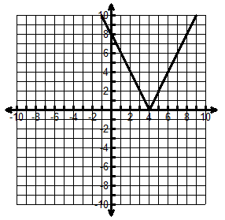

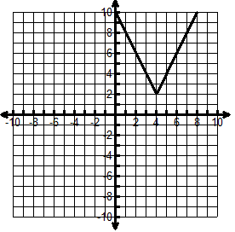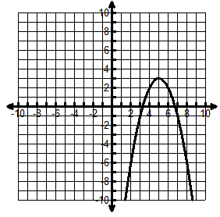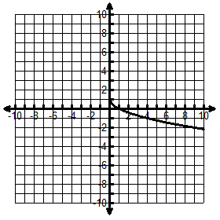

A. B. C. D.

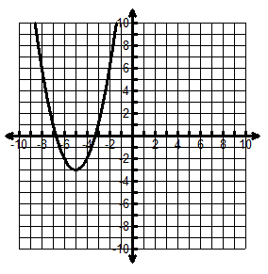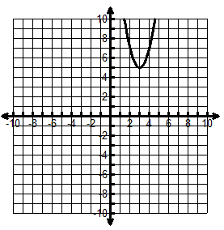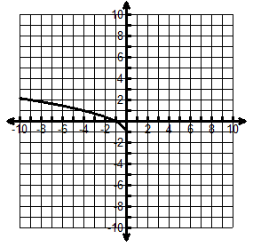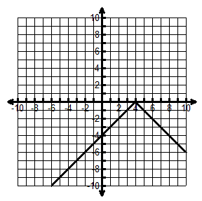

E. F. G. H.

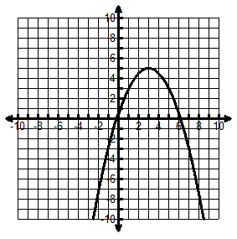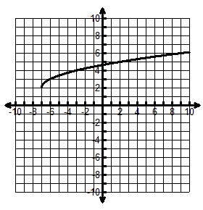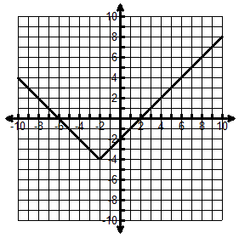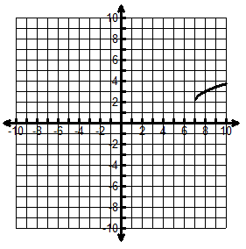

I. J. K. L.

38. Find the slope of the line between (5, 3) & (-2, 17)

39. Write the equation of the line that passes through (2, 6) with a slope of 3.

**A:** point-slope form: y – y1 = m(x – x1): **B:** Solve for y (i.e.: put in slope-intercept y = mx + b form):

**For each of the following: 1) List the transformations in the correct order. 2) Create a table to show the transformations on the key points. 3) State the vertex or endpoint. 4) Sketch the graph.**

40.  **Transformations:** **vertex or endpoint:________________**

41.  **Transformations:** **vertex or endpoint:________________**

42.  **Transformations:** **vertex or endpoint:________________**

43.  **Transformations:** **vertex or endpoint:________________**

44.  **Transformations:** **vertex or endpoint:________________**

45.  **Transformations:** **vertex or endpoint:________________**

46.  **Transformations:** **vertex or endpoint:________________**