Name:_________________________________________ Period:__________

**SM 2**

**7.2 Graphing Quadratic** **Functions: Vertex and Axis of Symmetry**

**State the vertex and graph each parabola. Clearly mark the vertex and four other points on the graph.**

1.  Vertex: ________ 2.  Vertex: ________

Form of the equation: _____________ Form of the equation: _____________

|  |  |  |
| --- | --- | --- |
|  | ***x*** | ***y*** |
|  |  |  |
|  |  |  |
| Vertex |  |  |
|  |  |  |
|  |  |  |

|  |  |  |
| --- | --- | --- |
|  | ***x*** | ***y*** |
|  |  |  |
|  |  |  |
| Vertex |  |  |
|  |  |  |
|  |  |  |

3.  Vertex: ________ 4.  Vertex: ________

Form of the equation: _____________ Form of the equation: _____________

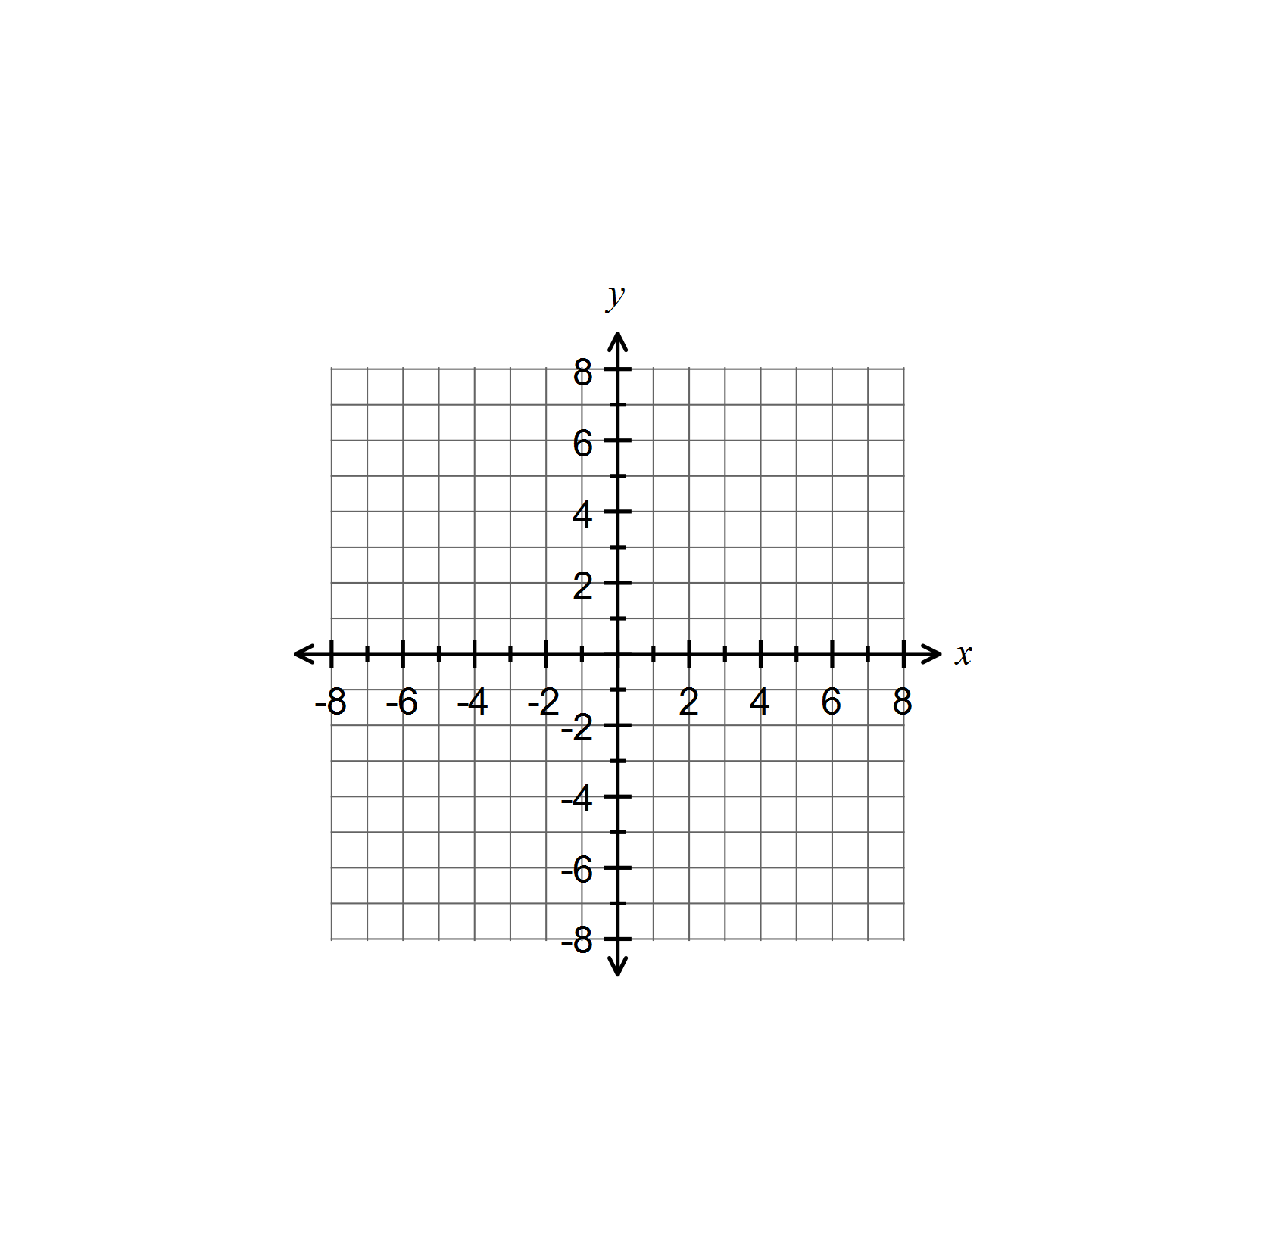

|  |  |  |
| --- | --- | --- |
|  | ***x*** | ***y*** |
|  |  |  |
|  |  |  |
| Vertex |  |  |
|  |  |  |
|  |  |  |

|  |  |  |
| --- | --- | --- |
|  | ***x*** | ***y*** |
|  |  |  |
|  |  |  |
| Vertex |  |  |
|  |  |  |
|  |  |  |

5.  Vertex: ________ 6.  Vertex:________

Form of the equation: _____________ Form of the equation:

$a=_______$ $b=_______$ $a=________$ $h=________$ $k=_________$

_____________



|  |  |  |
| --- | --- | --- |
|  | ***x*** | ***y*** |
|  |  |  |
|  |  |  |
| Vertex |  |  |
|  |  |  |
|  |  |  |

|  |  |  |
| --- | --- | --- |
|  | ***x*** | ***y*** |
|  |  |  |
|  |  |  |
| Vertex |  |  |
|  |  |  |
|  |  |  |

**Fill in the requested information for each function. Draw the graph. You need AT LEAST 5 POINTS!**

7. 



Vertex: _______________

Axis of Symmetry: _______________

Direction of Opening: _______________

Is the vertex a maximum or a minimum? _____________

Maximum or minimum value: _______________

*y*-intercept: _________________

Domain: ____________________

Range: _____________________

8. 



Vertex: _______________

Axis of Symmetry: _______________

Direction of Opening: _______________

Is the vertex a maximum or a minimum? ______________

Maximum or minimum value: _______________

*y*-intercept: _________________

Domain: ____________________

Range: _____________________

9. 



Vertex: _______________

Axis of Symmetry: _______________

Direction of Opening: _______________

Is the vertex a maximum or a minimum? _____________

Maximum or minimum value: _______________

*y*-intercept: _________________

Domain: ____________________

Range: _____________________

10. 



Vertex: _______________

Axis of Symmetry: _______________

Direction of Opening: _______________

Is the vertex a maximum or a minimum? ______________

Maximum or minimum value: _______________

*y*-intercept: _________________

Domain: ____________________

Range: _____________________